Customer Bill of Exchange Sent for Collection

Step1: Customer Bill of Exchange Payment

TRANSACTION CODE : F – 36

ACCESS PATH :SAP Easy Access → Accounting → Financial
Accounting → Accounts Receivable → Document Entry
→ Bill of Exchange → Payment

We get “ Bill of exchange Payment – Header Data” Screen;

Required Fields:

Document Date : To be entered
Customer Account : To be entered
Spl. G/L Ind. : To be entered as “B” (Bill of exchange Receivable)
Posting date : Default

Document Type, Currency, Period & Company code appear as default after it has been entered for the first time.

Press Enter Button

We get “Bill of Exchange Payment – Add Customer Item” Screen as under
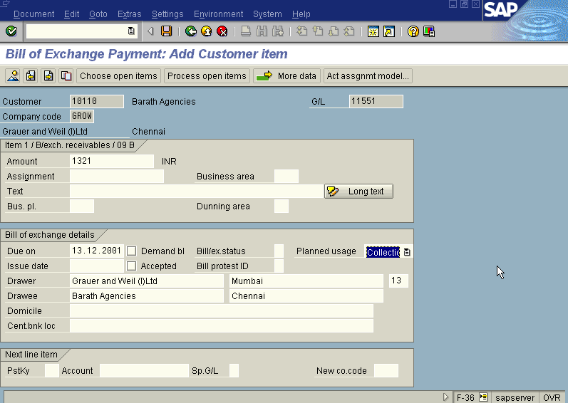
In the above screen fill the amount, due date and Planned Usage fields

Press Enter

Press Choose Open Item Button

We get “ Bill of Exchange Payment – Select Open Item” Screen as Under
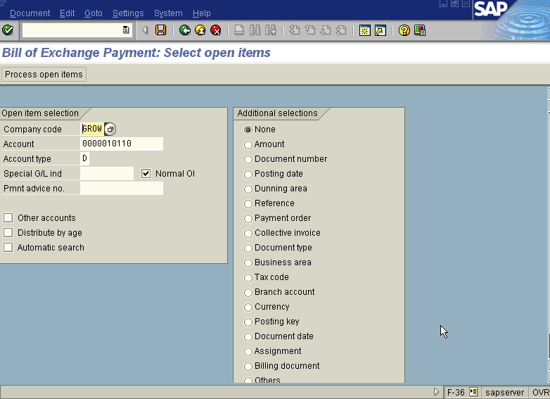

In the above screen Press Process Open Item button

We get “Bill Of Exchange – Process Open Item” Screen

In the above screen first select all Icon, So all the line items will turn blue then press Deactivate Icon so that all the items turn black. Then select the document by scrolling the screen. Once you have found the Document double click on the amount field of that document. Then the Not Assigned field in the above screen turns Zero.

Press Save Button

The system displays the message with document number
Take the note of the document number : 1400151.

To view the entries posted go to “Bill of Exchange Payment – Header data” screen
And click Document → Display or press Transaction Code FB03.

We get the Overview document screen with the entries as under
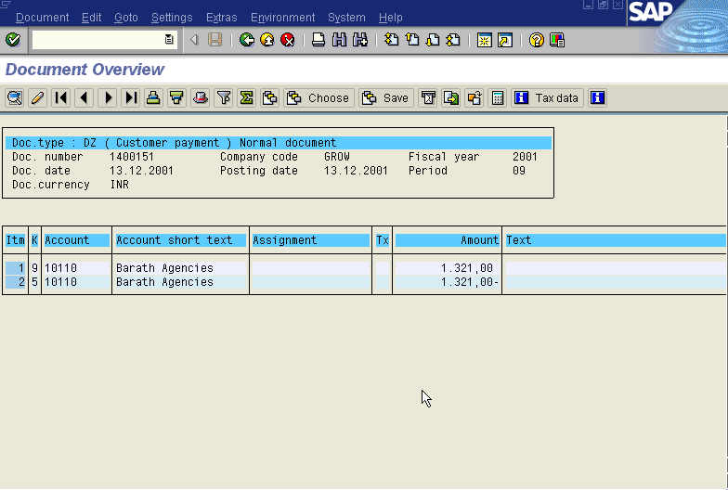

Step2: Customer Bill of Exchange Collection

TRANSACTION CODE : F – 34

ACCESS PATH :SAP Easy Access → Accounting → Financial
Accounting → Accounts Receivable → Document Entry
→ Bill of Exchange → Collection

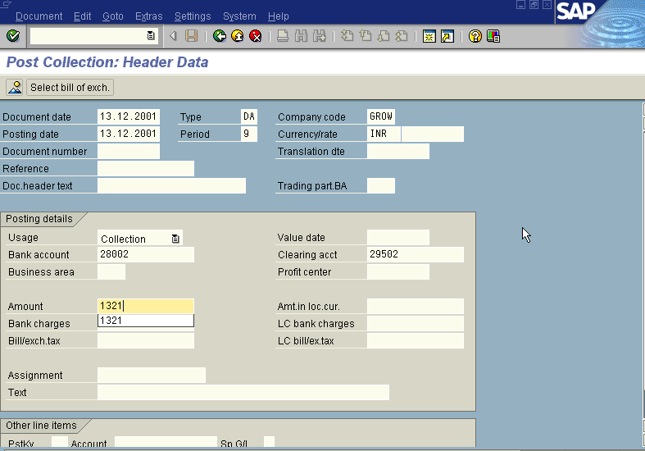
We get “ Post Collection – Header Data” Screen as under

Press Select Bill Of Exchange Button

We get “Post Collection- Choose Postings” Screen

In the above mentioned screen enter Bill of exchange document number eg: 1400151 in document number field. Incorporating the data in the relevant fields the system displays the screen as under
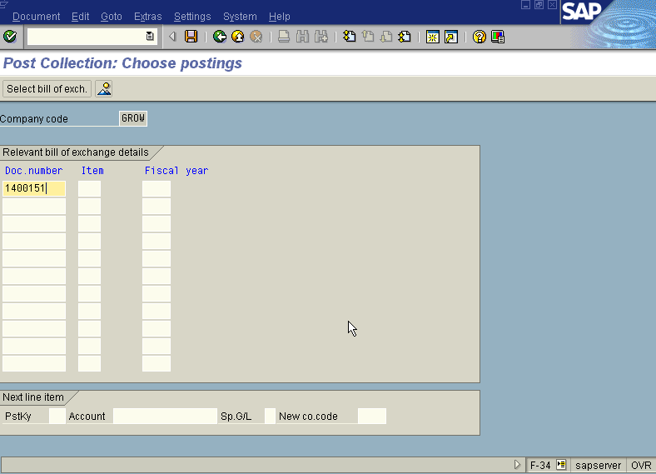

Press Enter

The System displays the message as under

Press save

The System displays the message as under

Take a note of the document number: 1600294

To view the entries posted go to “Post Collection– Header data” screen
And click Document → Display or press Transaction Code FB03.

We get the Overview document screen with the entries as under
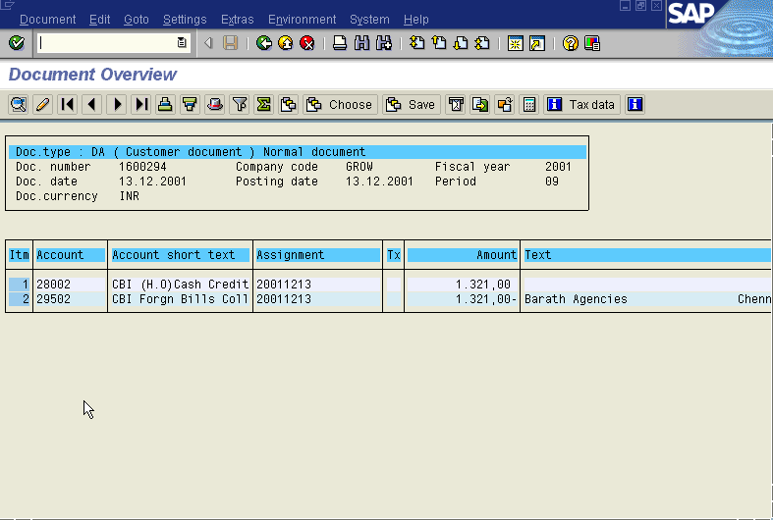
Step 3: Reversal of Contingent Liability

TRANSACTION CODE : F – 20

ACCESS PATH :SAP Easy Access Accounting Financial
Accounting Accounts Receivable Document Entry
Bill of Exchange Reverse Contingent Liability

We get “ Reverse Bill Liability – Header Data” Screen as under;

Required Fields:

Document Date : To be entered
G/L Account : Enter (11551 – Bill of Exchange- Domestic Reco. A/c)
Usage : To be set at “ Collection”
Document No. : To enter the Bill of Exchange document number
Customer Account : To be entered
Posting date : Default

Document Type, Currency, Period & Company code appear as default after it has been entered for the first time.

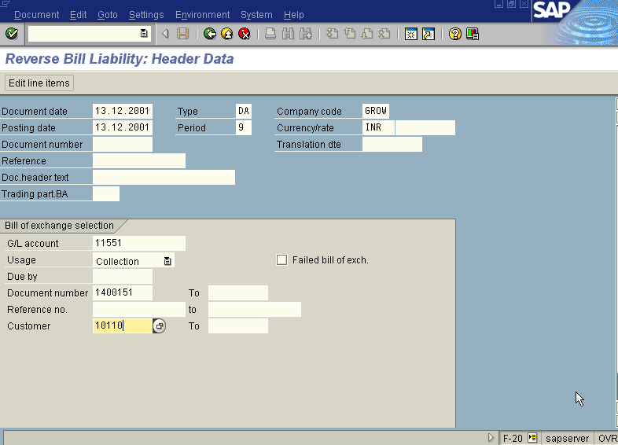
Press Enter Button

We get “ Reverse Bill Liability – Choose Postings” Screen as under
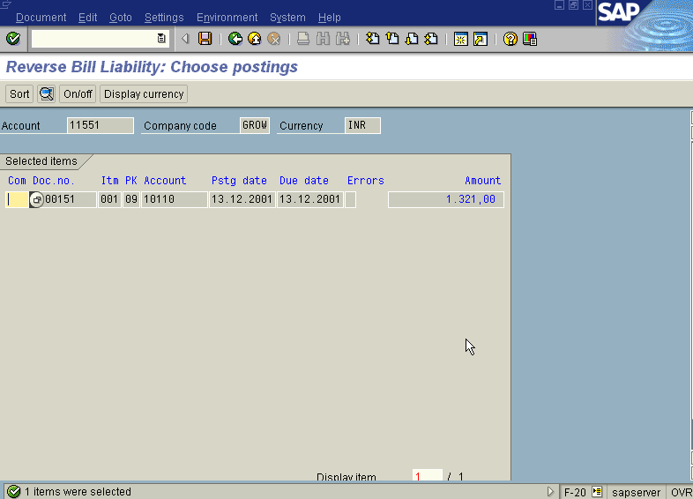

Press Save Button

The system displays the message as under

Take the note of the document number : 1600295.

To view the entries posted go to “Reverse Bill Liability – Header data” screen
And click Document → Display or press Transaction Code FB03.

We get the Overview document screen with the entries as under
